**Key Features for Patient Panel**

* **Profile**

It is the most important feature of an appointment booking app. With this feature, the patient will easily submit thier name, gender, residence, age, medical history, and other important information to the treatment procedure.

Thus, you should add this feature while creating an app like Practo. In order to make this procedure easy and smooth, you can seek the help of [**react native app development company**](https://www.techgropse.com/react-native-app-development), which is committed to providing the best practo app development services.

* **Find a Doctor or Clinic**

Practo healthcare app has a feature that helps the patient to search the profiles of doctors & clinics in thier area. These profiles include data about their qualifications and expertise, patient reviews, contact details, price per treatment, and other things that help you better decide which physician, doctor, or clinic to select for your requirements.

However, developing an app like Practo, you need to seek the help of an app development company that is committed to providing [**flutter development services**](https://www.techgropse.com/flutter-app-development-company) within your budget. This will help you make an app equipped with the latest features and technology.

* **Appointment**

This is another essential feature of the healthcare app for patients. With the help of this feature, users may browse a list of doctors, read their profess and book, and make an appointment with a doctor of their choice.

Plus, this feature always tells patients about a doctor’s availability and makes scheduling an appointment easy. However, developing an **app like Practo** is not an as easy task as it seems. Therefore, choosing **custom mobile app development** **services** from a custom flutter **app development company** is a great idea.

With years of expertise and in-depth knowledge, they will easily design an app that meets your business requirement and help make an appointment booking process easier and more convenient.

* **Real-Time Audio/Video Chat**

This is another important feature of healthcare apps like Practo. Having this feature, both patients can communicate through audio and video chat during a remote consultation. Using this app, doctors can recognize observable symptoms, allowing them to make an accurate diagnosis while patients may effectively discuss their issues.

Thus, you should add this feature when developing an app like Practo. In this job, you can also take the help of a mobile app development company. They will give you one of the best solutions that will help you to boost your business.

* **Medial Records**

This is another important feature a healthcare app should have. When patients create their accounts, they have access to medical records that contain all of thier information along with medical data and communication history.

If important, the healthcare documents can be shared with another specialist, spouse, or other family members. Hence, you should add this feature while building an app like Practo. In order to implement your idea into reality, you can also take the help of an [android app development company](https://www.techgropse.com/android-app-development) for opting the best  custom mobile app development services.

* **Medicine Delivery**

This is another feature you may add to the mobile app like Practo that allow customers to purchase a wide selection of drugs and medicines to manage thier health. In this case, they are required to search for a prescription or non-prescription medication by name or some other relevant information.

With this feature, the healthcare center can deliver the medicine on time, and patients never miss thier dose. This is the reason that an appointment booking app should have this feature. For this job, you can also hire dedicated developers who have years of experience in this field.

* **Payment Gateway**

This feature allows the patient to make online payments by paying through the different modes of payment. With the help of this feature, users may easily make money while booking an appointment with a doctor.

Hence, when developing an app like Practo, don’t forget to add this feature. However, building an app on your own is not easy without any skills or other details. So, you can take the help of a [**custom iPhone app development**](https://www.techgropse.com/iPhone-app-development)company that has years of experience in this field.

**Features of Doctor Panel**



The doctor panel will make it simpler for doctors to contact their patients by allowing them to do so through video calls or chat. Therefore, on the doctor’s dashboard, you should also add the following features:

**Profile**

Apart from the user panel, it is must important feature of the doctor panel. So, you need to add this feature to the doctor panel. It will help to add the specialist’s name, address, photos, specialty, and availability.

This app may also share information about their experience and education. So, while developing an**app like Practo**, add this feature. For this task, you can also seek the help of a **mobile app development company**.

* **Appointment Management**

You should also add this feature when developing an app like Practo. It will allow the doctor to schedule and list a large number of remote appointments at once. This app also manages daily appointments while giving patients on-time service.

However, you should seek the help of a mobile app development company to practo app development. This wil help you to develop an app that works appropriately.

* **Patient Records & Medical History**

In order to provide one of the best services, it is required to have this feature. With the help of this feature, doctors can see their patient’s medical records through the app to make effective and efficient diagnoses.

Having a complete record, they will easily find solutions instantly to keep both the patient and themselves safe and healthy.

* **Prescription**

After checking the patient’s condition, it is required to provide medication. Thus, you should add a prescription feature to your app. With the help of this feature, patients can purchase their medication.

If you are not able to add this feature on your own, you need to call an app development company. They have years of experience, so they easily do this task and ensure you and your patient never face difficulty using an app like Practo.

* **Transaction & Analytics**

This feature wil assist you in keeping all the transactions secure and safe. It will also show whether the doctor has performed a proper job. Therefore, it is necessary to add this feature while building an app like Practo.

**Key Features of Admin Panel**

Admin Panel keeps patient records, analyzes and reports on data, and many more. In order to make an app successfully,  you need to add some required features in the admin panel. Some are mentioned below:

Payments:

It is required to add this feature to the admin panel while developing an app like Practo. This will help them to manage the payment.

[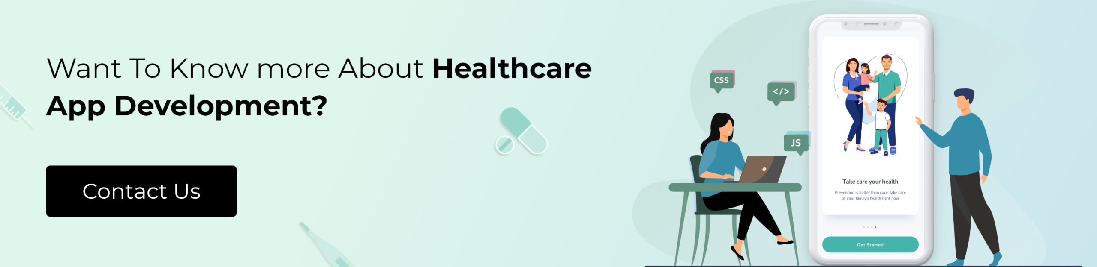](https://www.techgropse.com/contact)

* **Manage Users**

This feature plays an important role im practo app development. Therefore, you should add this feature to your application. If you cannot do that, it is time to seek the help of a mobile app development company.

* **Manage Doctors**

This feature is a must required. So, make sure that your app should have a manage doctor feature. For this, you can also seek the help of react native app development company to complete this job.

* **Push Notification**

It is always necessary to have a push notification feature in your app. It will allow sending notifications to users regarding new offers and products. So, while creating an app like Practo, make sure that you have this feature.

**Cost of Developing a Healthcare App Like Practo**

Once you decide on the feature of an app like Practo, the first question is how much the cost of practo app development is. Of course, it is a big investment, so you can spend millions building a healthcare app. However, various factors impact production expenses when building a mobile app.

For custom iPhone app development, the optimum technology stack selection is important. Another crucial framework is the app’s interface, which attracts the user’s attention. As a result, to engage the users, you must include animation, images, and other sorts of UI/UX.

According to an idea, healthcare app costs may be between $120k to $200k to develop. Usually, it can depend on several factors, along with the time frame and complexity of the application. Apart from design, framework, and features, geographical location also plays an essential role in mobile app development costs.

Of course, several mobile app development companies around the world take different charges from their clients. Below we mentioned a table that will help you to determine the cost of mobile app development.

| Country | App Development Cost per Hour |
| --- | --- |
| USA | $100 to $150 |
| Europe | $70 to $ 120 Per Hour |
| India | $40 to $ 80 Per Hour |

Hopefully, this information may be helpful to you. However, it is just an idea, not reality. So, before making a decision, ask the exact cost of the practo app development with a reliable mobile app development company.

**The Last Note**

The healthcare industry is growing rapidly, which is why the demand for appointment booking apps is becoming high. Therefore, businesses invest their money in building an app like Practo. This will help the healthcare company to connect with the patients virtually.

Plus, it is always beneficial to users because they don’t need to stand in a long queue and wait for hours to book an appointment with the doctors. With the help of an app like Practo, they communicate with the doctors and discuss their problems with ease.

Thus, it is necessary to have an app for every hospital and clinic. However, developing an application is not an easy task. In such a situation, you should seek the help of react native app development company.

They will assist you in developing an app like practo that has amazing features. So, find out a reliable name that has years of expertise and skills to develop an app. For this, you should do research online and offline.

**What Features Should an App Like Practo Have?**

Successful healthcare applications are developed using the target audience’s needs and implementing those needs in the form of features. Some noteworthy features just cannot be overlooked while developing a healthcare app. Notable features help doctors and patients to make their communication easier and more effective.

**Patient Panel Module**

* **Profile** - To create a profile, a patient submits their name, residence, gender, age, medical history, and other critical information required to begin the treatment process.
* **Find Doctor or Clinic**- Practo provides patients with a way to search for profiles of doctors & clinics in their area. Their profiles include information about their qualifications and experience, contact details, patient reviews, price per treatment, and other interesting insights that help you make a better decision about which doctor or clinic to choose for your needs.
* **Appointment** - One of the main advantages of healthcare apps for patients is that users may browse a list of doctors, read their profiles, and make an appointment with the doctor of their choice. This feature tells patients about a doctor's availability and makes it easy for them to schedule an appointment.
* **Real-Time Audio/Video Chat** is another essential element in fostering patient-doctor confidence. Both parties can communicate via audio and video chat during a remote consultation. Doctors can recognize observable symptoms, allowing them to make a more accurate diagnosis, while patients may effectively convey their difficulties, just as they would during an in-person session.
* **Medical Records** -  When patients create their accounts, they have access to Medical records that contain all of their information, including medical data and communication history. If required, the healthcare documents can be shared with another specialist, spouse, or other family members.
* **Medicine Delivery** - An additional feature you can add to the already existing online store that allows customers to purchase a wide selection of drugs and medicines in order to manage their health. In this case, all they need to do is search for a prescription or non-prescription medication by name or some other relevant key term such as instructions on how it should be taken, then place an order and have it delivered timely.
* **Payment Gateway** - Allow patients to make online payments by paying through the different modes of payment available, for example, using a debit card or credit card.

**Doctor Panel Module**

The doctor module will make it simpler for doctors to contact their patients by allowing them to do so via video calls or chat. On the doctor's dashboard, they'll find a number of helpful features.

* **Profile** - The name, address, photos, specialty, and availability of the doctor must all be provided. They may also share information about their expertise and education.
* **Appointment Management** - With the current circumstances,  applications may get overburdened by the influx of appointments. This necessitates using a powerful feature capable of scheduling and listing a large number of remote appointments at once. The app requires an appointment management tool to enable the doctors to manage daily appointments while giving patients on-time service.
* **Patient Records & Medical History -**Doctors should be able to see their patients' medical records via the app in order to make effective and efficient diagnoses. Having a complete record will enable them to find solutions more quickly to keep both the patient and themselves safe and healthy.
* **Prescription** - Doctors should have the capacity to provide prescriptions directly from the app. Patients can use these prescriptions to purchase medication at medical institutions. The bottom line is that all of a patient's information is accessible to easily follow their appointments and results (like treatment plans, prescriptions, and medications).
* **Transaction & Analytics** - This software will help in keeping all the transactions organized and safe. It will also highlight whether the doctor has performed a proper job or not and how frequently he makes appointments with his patients.

**Admin Panel Module**

Admin Module keeps patient records, analyzes and reports on data, manages financial affairs, and more. Ensuring security measures ensure the complete safety of sensitive user information while cleverly implemented functions enable the seamless operation of your system.

Features:

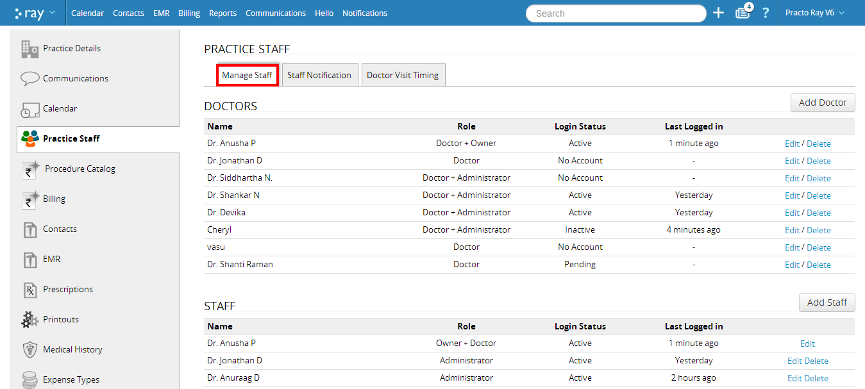

* Dashboard
* User Management
* Manage Appointments
* Manage Doctors
* Management of Diagnostic Center
* Clinic Administration
* Delivery Personnel Management
* Payout Administration

**Medicine Delivery Panel**

The delivery panel is a window that gives members access to the order database containing the contact information, timing, and status of orders on the site. It ensures that all orders can be verified in one place for delivery personnel to provide their services quickly and easily.

* My Account
* View Delivery
* Notification

**How to Develop a Healthcare App Like Practo?**

* **Goal** - Before going into the specifics of how to create an app (i.e., its features), you should be sure to explain why you want to build a healthcare app like Practo. Your application needs to achieve two primary purposes, ‘your appropriate user goal’ and Your business goal. Therefore, by developing your mobile application, you'll also want to make sure it can complete the following questions: Why do users need this app? How will your app accomplish this goal? How does this benefit my business? What potential challenges may arise from a mobile app attempt like mine?
* **Market Research** - Market research is a method of discovering and analyzing information about the market. It helps you identify what your competitors are doing, how they are faring, why people choose to buy their products instead of yours, and more. Understanding this information can be immensely helpful in shaping or targeting your product or service offering and figuring out how to best market it. You also can gain insight into how much such an app would cost you to make versus the money it takes in, thus refining your idea if needed based on actual inputs and market demand before actually going out there and building anything.
* **Features and User Flow** - Once you have compiled your research and are certain of your approach, it's time to put pen to paper. This should build a more concrete picture of what you want the product to be and how it will become a reality. Write all the features you wish to add and draw an example of user flow. Describe how the features will work, who will use them, and why people would buy them now or in the future. It helps you and developers who may need to make sense of this data, which affects every aspect of the project from conception to delivery.
* **Eliminate Irrelevant Features -** With these detailed texts, you can get a general idea of what can be removed from your application. Initially, it is recommended to keep only the main idea of your application. For example, you can easily update or add new features over time and accomplish all of your goals with accurate improvements. Removing less essential features will simplify basic application development and save your initial budget. It will also allow you to quickly bring your latest app to market, saving on application development costs.
* **Hire an app development agency**- Building a healthcare application, especially one like Practo, is no small feat. Even experienced agencies can sometimes get overwhelmed by technical hiccups and unforeseen budget problems, so it’s certainly not for the faint of heart. If you are to go against our advice and try your luck at getting such a complex system built with freelancers instead of something more reliable like an outsourcing agency, be prepared to encounter several challenges that could eventually lead to you losing a lot of money entirely.

This is why it’s important to team up with a quality development agency that will create your app to align with your vision and handle any challenges you might encounter as you work together. This way, you also get to enjoy reduced costs thanks to the fact that many firms are open to flat rates - this means that whatever happens with the project, the agency won't charge you extra and will stick by their quote!

So hire an [**app development agency**](https://www.raftlabs.co/services) and let your imagination become a reality.